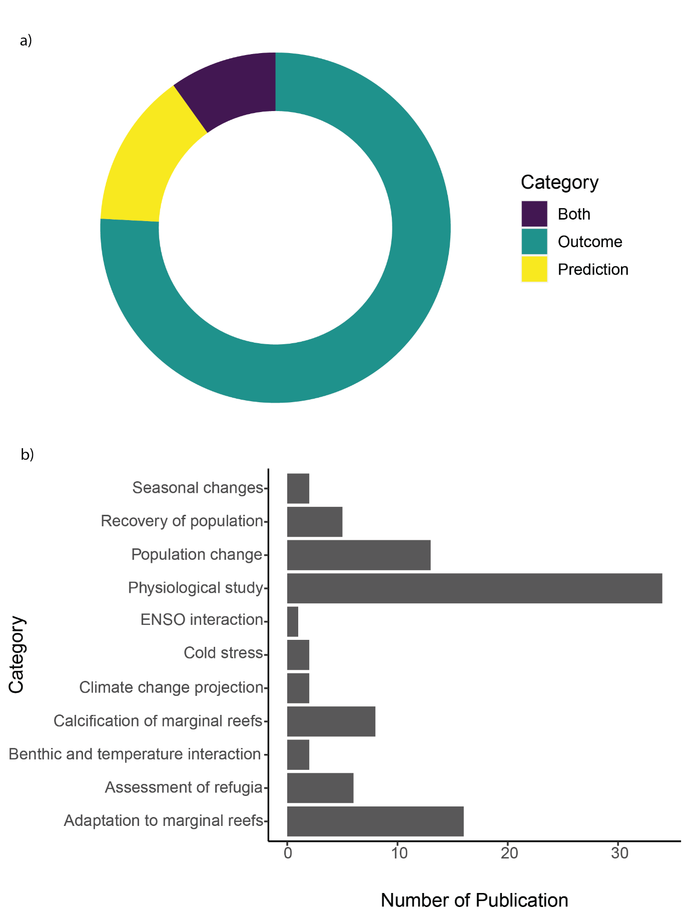

Figure 12 Proportion of literature included in this systematic map that include outcome and/or prediction, created using R package ggplot2. b) Categories of outcome/prediction and their number of publications respectively, created using R package ggplot2.